Public Relations Communication
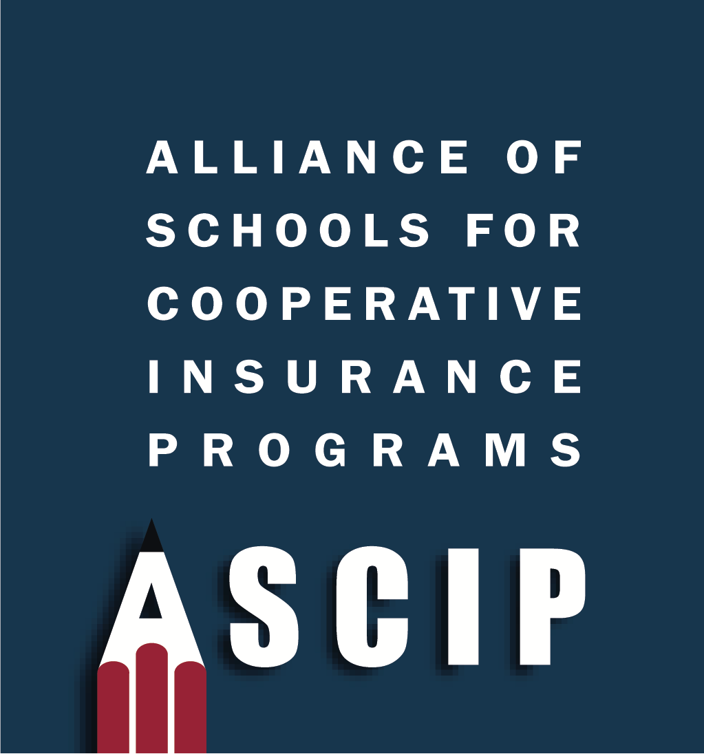
Best Practices

Public Relations Defined 2
Effective Public Relations Program 3
The Public Relations Planning Process 4
Crisis Communications 6
Example Crisis Response Procedures 8
Example Crisis Analysis Worksheet 9
Example Crisis Messaging Worksheet 10
Example Communications Checklist 11
Example Press Inquiry Log 12
Example Communications DO’S and DON’TS 13

Public Relations Defined

Public relations is the management function that establishes and maintains mutually beneficial relationships between an organization and the public to whom its success or failure depends.

Public relations looks after reputation, intending to earn understanding and support, as well as influencing opinion and behavior. It is the planned and sustained effort to establish and maintain goodwill and mutual understanding between an organization and its publics.

The National School Public Relations Association (NSPRA) defines public school relations as the following:

A planned, systematic management function, designed to help improve the programs and services of an educational organization. It relies on a comprehensive, two-way communication process involving both internal and external publics to stimulate a better understanding of the role, objectives, accomplishments, and needs of the organization.

Educational public relations programs assist in interpreting public attitudes, identify and help shape policies and procedures in the public interest, and carry on involvement and information activities that earn public support and understanding (www.nspra.org).

For sample communication templates please contact your ASCIP Risk Services Consultant.

Effective Public Relations Program

A good public relations program can help you gain support for your district initiatives in some key ways.

Taxpayer support
Since school funding is provided by revenue from taxpayers, PR is critical to build and maintain public support for education. PR departments must be transparent and aggressively promote the district programs to instill public confidence.

Ensure public engagement
It’s imperative that the district actively engage the public in meaningful dialogue about education and seek input into critical decisions that impact students.

The 24/7 media cycle
School communication needs have increased dramatically and become more complex. The district needs to develop and execute its communication plans through both print/electronic media and face-to-face communication, and to handle relations with the multitude of media that call the district weekly.

Education is being scrutinized
From taxpayers, business groups, and others. The district needs to publicize the positive news about student/staff achievement and programs and to develop a coordinated proactive rather than a reactive, approach that anticipates problems before they develop. If there is no positive communication from the district, the critics' voices are the only ones that will be heard.

Ethics and conduct
In a public information or communications position is it critical that at least the following directives guide the communication:

- The pursuit of the public interest through truth, accuracy, good taste, and fairness.
- Have good judgment in releasing information and not intentionally disseminate misinformation or confidential data.
- Be aware of personal influence, avoiding promises or granting of unprofessional advantages to others.
- Refrain from accepting special considerations for influences on organizational decisions.
- Avoid unauthorized use of organizational facilities, resources, or professional services for personal gain or promotion of the candidacy of aspirants to elected offices.

The Public Relations Planning Process

The public relations/communication efforts should be planned on a systematic (often annual) basis to support the achievement of your goals and objectives.

Step #1: Define Your Objectives
Use a variety of assessments. Begin by meeting with the superintendent and school board to discuss their priorities and objectives for district public relations. Know the district mission and goals and be prepared to discuss how your program can help achieve those goals.

Sample objectives:
- To grow enrollment numbers
- To increase awareness of the district’s achievements
- To achieve the support of the upcoming bond measure on the ballot
- To attract award-winning teachers

Step #2: Evaluation of Current Perceptions
Internal and external research. Before structuring your plan, you must be aware of where the district stands in the eyes of both staff and the community. Base your research on your district mission and goals and use several methods.

Questions to ask:
- Who are our publics?
- What are our publics' overall perceptions of our district?
- What "hot issues" are circulating among staff and the community?
- What issues affecting other school districts may soon be coming our way?

Research tactics to consider:

- National studies
- Census data
- Telephone logs – calls to the district
- Media reports/content analysis of media coverage
- Interviews with community opinion leaders
- Focus groups
- Written or telephone surveys

Step #3: Identify Your Target Publics
These "targets" are the groups of people that need to be reached to achieve the goals. Primary publics, which are those most important to achieving set goals, can include the following:

- Students
- Parents
- Employees
- District taxpayers
- News media
- Other community stakeholders (civic and business leaders, elected officials)

Step #4: Desired Outcomes
Identify the desired behavior of the publics; this is a critical step for the plan to be successful. You must decide what you want the program to do. Do you want to provide information, reinforce, or change the behavior of certain publics? These questions need an answer before developing strategies and creating tactics.

Step #5: Identify Strategies and Tactics
Create strategies and tactics for reaching publics. Strategies are overall procedures, like developing a media kit that provides general information about the school district.
Tactics are the actions needed to carry out the procedures, for example: writing the press release or printing the folder for the district media kit.

Step #6: Implementation
After management/board approval, put your plan into action. Keep track of your efforts and prepare regular reports of progress. Stay flexible to feedback and prepare to refine along the way because Step #8 is evaluating the effectiveness of your plan.

Crisis Communications

One of the most visible and difficult public relations functions is communicating effectively when a crisis threatens the community’s trust in the district. Even more, the reason you need a solid public relations strategy and program in place before a crisis hits.

If a district has been diligent in its public relations and communications efforts, a crisis’ potential negative impact can be mitigated.

Crises situations are usually handled like fires, and emergency crews must go into action. Don’t let misinformation and elevated emotions take control of the situation. Here are some imperative steps to controlling information and minimizing the possibility of damaging the district’s reputation.

#1: Get your facts straight
Don’t rely on speculation. Go to the source and ensure that you have the most accurate and up-to-date facts about the situation and the individuals involved.

#2: Assess the situation
Scan all communication channels (newspapers, blogs, broadcast news, community influencers, parents, etc.) and assess where efforts need to be focused. Distribute accurate information to the most appropriate and necessary channels.

#3: Lock down your key messages
Draft concise, accurate, and effective messages relating to the crisis. An empathetic and compassionate tone should ALWAYS guide messages during crises. Here are the basic questions you’ll need to answer:

- What is the problem?
- When did it start?
- Was it resolved? If so, when? If not, when will it be, and what is the solution?
- Where can people go to get answers?
- How can this be avoided in the future?

#4: Identify your district representatives
During a crisis, the media will exhaust all possible avenues to get information from the district. During the PR general planning process, designate who will provide comments to the media, sometimes this will be the office of communications or the superintendent, and establish the lines of communication.

The representative should have a key message and full knowledge of the situation. Instruct all other faculty and staff to direct inquiries to the approved source.

Send out a district-wide email with an explanation of the crisis and instructions on lines of communication.

#5: Evaluate and respond appropriately
Evaluate the effectiveness of communication efforts. Did the discussion wane or grow? Adjust the message accordingly.

Keep in mind that not ALL comments warrant a district-sponsored response, but be aware of blog comments, social media discussions, news threads, etc. and stay abreast of where the discussion is and where it may be headed. For high-level, mass-public responses, an op/ed or press conference may be appropriate

Example Crisis Response Procedures

Crisis
Occurs

Crisis Analysis
Worksheet
Crisis
Messaging
Worksheet
Distribute to Crisis
Management
Team
Assign tasks
Prepare/Refine
Communications
Documents

Talking points,
statement,
release, etc.
Communications
Checklist
Follow progress
Press Inquiry Log

Record information
as the calls/emails
are received
Update Crisis Analysis
Worksheet

As new developments
occur and as new
contacts are made

Example Crisis Analysis Worksheet

- How did we learn about the crisis?

- Briefly describe the crisis:

- In addition to members of the Crisis Management Team, are there other personnel who can provide vital information when preparing a response? Provide their names and contact information:

- Does the crisis involve a specific school? If so, where and how?

- Are there specific stakeholders who can provide secondary messaging in this crisis? Who will contact them?

- Does the crisis involve any public officials? Legislators, department of education staff, etc.?

- Are there particular sensitivities in this area that we need to consider in our messaging?

Example Crisis Messaging Worksheet

- Organization Objectives:

- Communications Objectives:

- Audiences:
Staff | Parents | Community

- Key Messaging:
Staff | Parents | Community

- Backup/Data:
Staff | Parents | Community

Example Communications Checklist

□ Alert/Brief Crisis Management Team

□ Assemble Crisis Management Team, complete Crisis Analysis Worksheet

□ Complete Crisis Messaging Worksheet

□ Alert affected offices

□ Activate press inquiry log

□ Develop and continually update worksheets, talking points, and Q&A

□ Begin communications with key stakeholders, providing specific messaging

□ Communicate key messages frequently – invite media and others to raise questions/concerns during each communication

□ Monitor media and stakeholder responses – address any inaccuracies or inconsistencies immediately

□ Continually update analysis worksheet, messaging worksheet and statements during the crisis

□ Anticipate possible scenarios during the crisis and prepare responses

Example Press Inquiry Log

- What is your name?

- What media organization do you represent?

- What is your contact information/the best way to reach you?

- What story are you working on?

- Are there specific questions you have?

- Are there particular answers I can get for you?

- How familiar are you with our district?

- Can I provide you with a background?

- What is your deadline?
END YOUR CONVERSATION WITH “I WILL CALL YOU BACK” &
MAKE SURE TO FOLLOW THROUGH

Example Communications DO’S and DON’TS

DO:
- Stay on message! Think of your core message as an island. Reporters will try to push you off – your job is to stay on your island tactfully.
- If you think you're too repetitive, you’re doing it right.
- Anticipate questions and formulate answers.
- Preparation is key – know your topic, know what you want to say.
- If time allows, research the reporter(s) you’ll be speaking with. Try to ascertain or anticipate their “angle.” By the time a reporter calls, they usually have an existing framework already developed (need filler, need help connecting the dots, etc.).
- Have prepared remarks in front of you, but try not to read verbatim.
- Watch your tone and demeanor.
- Make eye contact with your audience, if in person.
- Mistakes happen: calmly correct yourself and move on, don’t worry about it.
- Visualize how you would ideally like the article and its headline to read or be seen tomorrow and work backward from there.
- Help your interviewer prepare. Provide background info, charts, statistics, etc. that support /illustrate your point(s).
- Don’t start speaking as soon as a question is asked, pause, and collect your thoughts.
- Remember your audience – use layman’s terms.
- Speak in complete sentences. Use short sentences, not one-word answers.
- Open with your message…expand on it…then close with it, too.
- Respect deadlines.
- Correct inaccuracies.

DON’T:
- Lie to a reporter.
- Sound or look defensive.
- Talk to a reporter when he/she has caught you off guard.
- Be afraid to say, “I don’t know – I’ll have to get back to you,” or “I haven’t had a chance to see it yet – let me get my hands on it, and I’ll call you back.”
- If you’re not expecting the call, find out what they’re calling about before you start the interview.
- Don’t talk if you’re not prepared. It’s ok to say I will call you back.
- Never feel compelled to do an interview on the spot.
- Cut off the questioner.
- Don’t speak with your hands or get fidgety.

